NAME | Darshana Chothave
UID | 2021300021
SUBJECT | DAA
EXPERIMENT NO. | 1
CLASS | SE COMPS-A
BATCH | D
AIM | To implement the various functions e.g. linear, non-linear, quadratic, exponential etc.
PROGRAM | #include <stdio.h>  #include <math.h>  int main()  {  //int i,n=100;  for(int i=0;i<=100;i++)  {  printf("Number is : %d and cube of the %d is :%d \n",i,i, (i*i*i));  }  printf("-----------------------------------------------\n");  for(int i=0;i<=100;i++)  {  printf("The number is: %d\n",i);  }  printf("-----------------------------------------------\n");  for(double i=0;i<=100;i++)  {  printf("The value of ln.%f is: %f\n",i,log(i));  }  printf("-----------------------------------------------\n");  for(double i=0;i<=100;i++)  {  printf("The value of ln(ln.%f) is: %f\n",i,log(log(i)));  }  for(double i=0;i<=100;i++)  {  printf("The value of %f.2^%f is: %f\n",i,i,i*pow(2,i));  }  printf("-----------------------------------------------\n");  for(double i=0;i<=100;i++)  {  printf("The value of (3/2)^%f is: %f\n",i,pow(1.5,i));  }  printf("-----------------------------------------------\n");  for(double i=0;i<=100;i++)  {  printf("The value of 2^2^%f is: %f\n",i,pow(2,pow(2,i)));  }  printf("-----------------------------------------------\n");  for(double i=0;i<=100;i++)  {  printf("The value of 2^2^(%f+1) is: %f\n",i,pow(2,pow(2,i+1)));  }  printf("-----------------------------------------------\n");  for(double i=0;i<=100;i++)  {  printf("The value of lg.%f is: %f\n",i,log10(i));  }  printf("-----------------------------------------------\n");  for(double i=0;i<=100;i++)  {  printf("The value of 2^lg.%f is: %f\n",i,pow(2,log10(i)))  }  }
OBSERVATION | 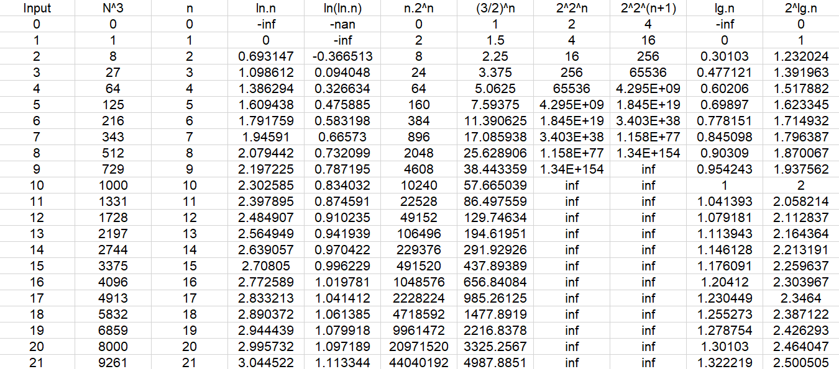  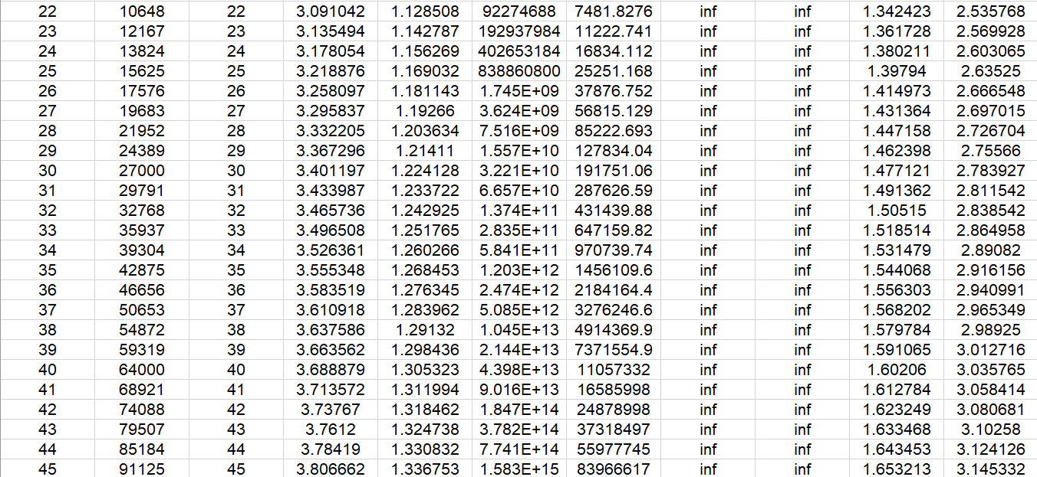  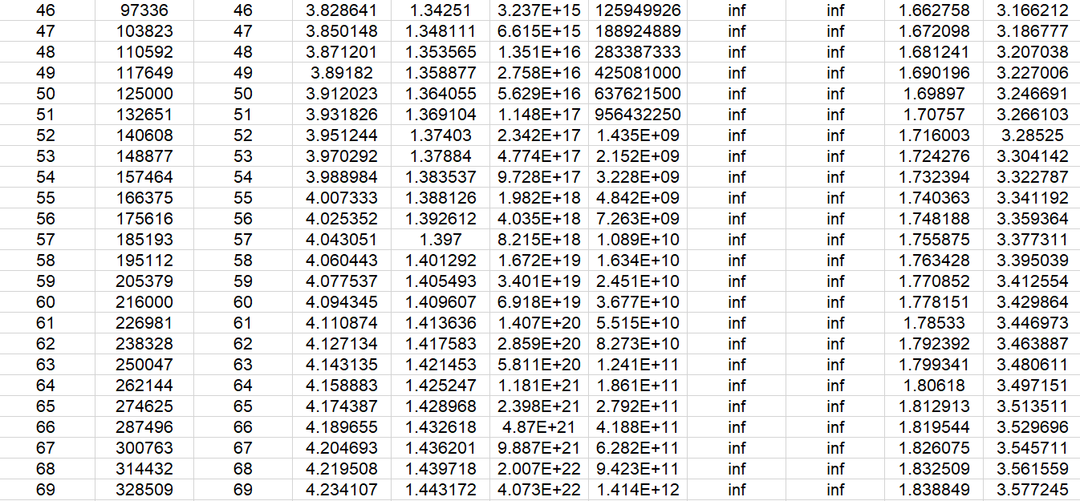  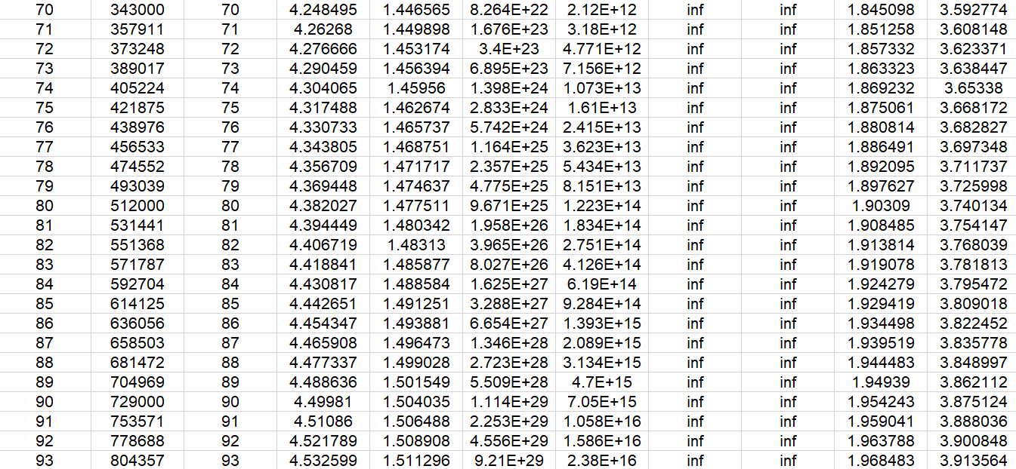  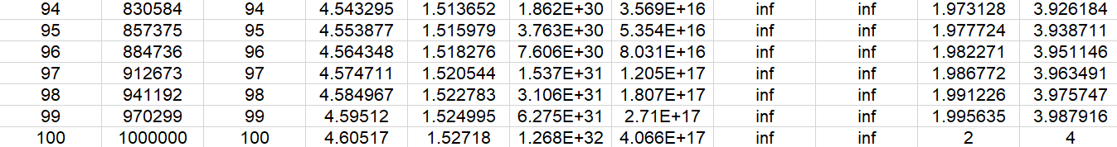  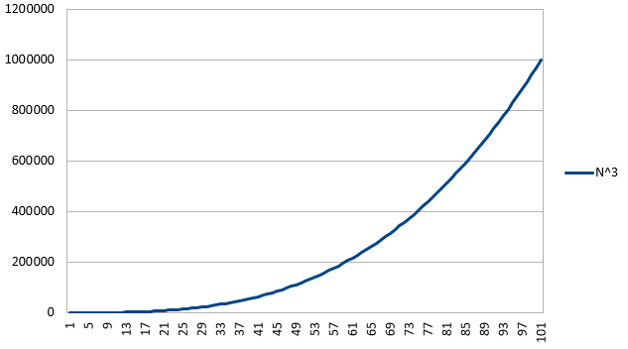  Increasing cubically  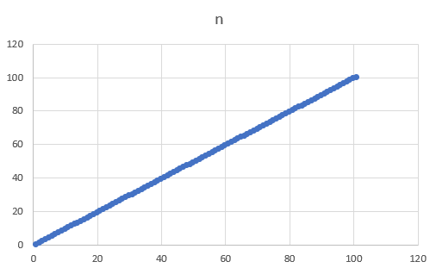  Increasing linearly with value.  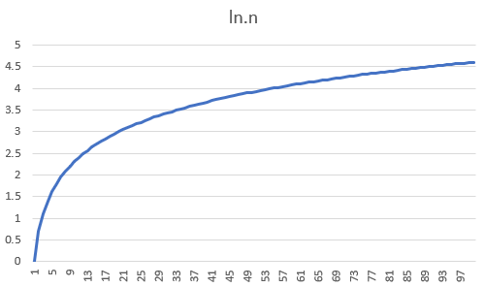  Increases in logarithmic form  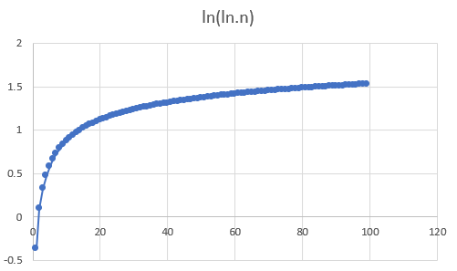  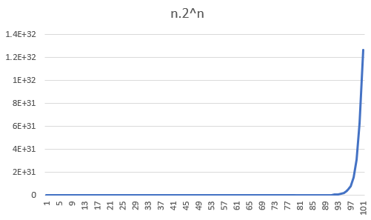  Increases exponentially  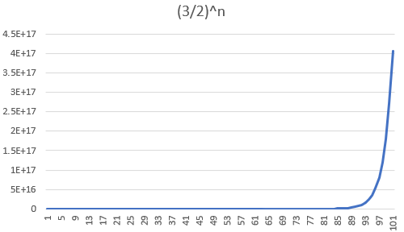  Increases 1.5 folds with increase in each value  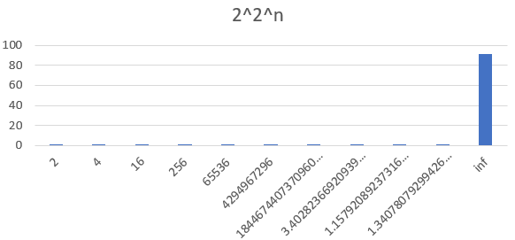  Increases exponentially  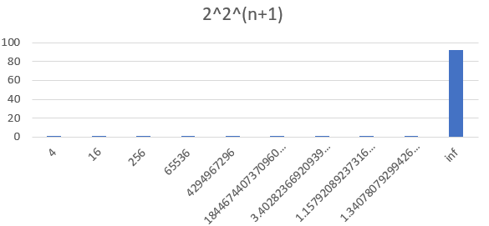  Increases exponentially  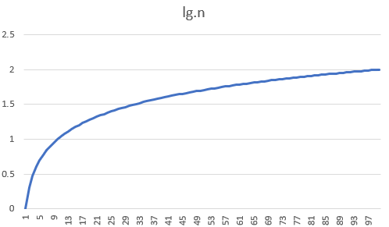  increases logarithmically  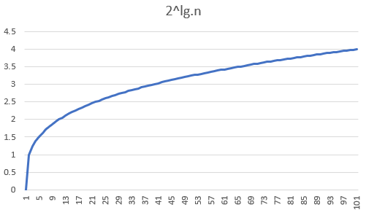
CONCLUSION | The above experiment made me understand about the various exponential,linear and logarithmic functions while implementing them in the C programming language.Each spike is seen with a very big gap as all the functions are higly increasing.

